# **Section 1 Assignment (108 points) - Sets**

To receive credit, you must either show your work on the worksheet or explain how you got the answer.

1. (6 points) Cardinality of a set defined by a Cartesian product. 71/108
2. (3 pts) What is **|** {1, 2, 4, 5, 7, 8}3 **|**

3 These questions confused me because I didnt know it each number in the sets were an element or if the whole group between the {} were because it was {}^3 I thought it 3 elements instead of 6^3

1. (3 pts) What is **|** {a, b, c, d, e}2 **|**

2 Same problem as the previous question, it was 5 elements squared and not 2 elements of everything between the {}



1. (10 points) Express each set in roster notation. Express the elements as strings, not n-tuples.
2. (5 pts) A3, where A = {a, b}

{(a, a, a), (a, a, b), (a, b, a), (a, b, b), (b, a, a), (b, a, b), (b, b, a), (b, b, b)}

1. (5 pts) B2, where B = {1, 2, 3}

{(1,1), (1,2), (1,3), (2,1), (2,2), (2,3), (3,1), (3,2), (3,3)}

1. (18 points) Set Properties. Use the following sets to answer the questions.

U = {a, b, c, d, e, f, g, h, i} A = {c, d, e, i, h} B = {a, b, c, d, e, f, i, h} C = {d, {e, f}, g, h}

* 1. (3 pts) T / F {a, b, c, h, i}  U

T

* 1. (3 pts) T / F {}  C

F

* 1. (3 pts) T / F {e, f}  C

T

* 1. (3 pts) T / F {e, f, g, h}  C

F

* 1. (3 pts) T / F A  U

F Im not sure what I did wrong here I think I may have just put the wrong letter is all

* 1. (3 pts) T / F A ⊂ B



T

1. (36 points) Set Operations. Use the following sets to answer the questions.

U = {a, b, c, d, x, y, z} A = {b, c, x, y} B = {a, b, c, z} C = {a, b, d, y}

* 1. (6 pts) What is A **** C?

{a,b,c,d,x,y}

there are 6 different characters in total

* 1. (6 pts) What is A ∩ B ∩** **C?

{b}

b is the only one that they all have in common

_____

* 1. (6 pts) What is A ∩ C?

{a,c,d,x,z}

A ∩ C = {b,y} so everything that is not b or y

* 1. (8 pts) List all subsets of C ∩ (A  B).

A  B = {a,b,c,x,y,z} Here I just didnt list all the subsets and only listed

C ∩ {a,b,c,x,y,z} one

{a,b,y}

* 1. (10 pts) Draw the Venn diagram for these sets (U, A, B, C).

*U = {a, b, c, d, x, y, z} A = {b, c, x, y} B = {a, b, c, z} C = {a, b, d, y}*

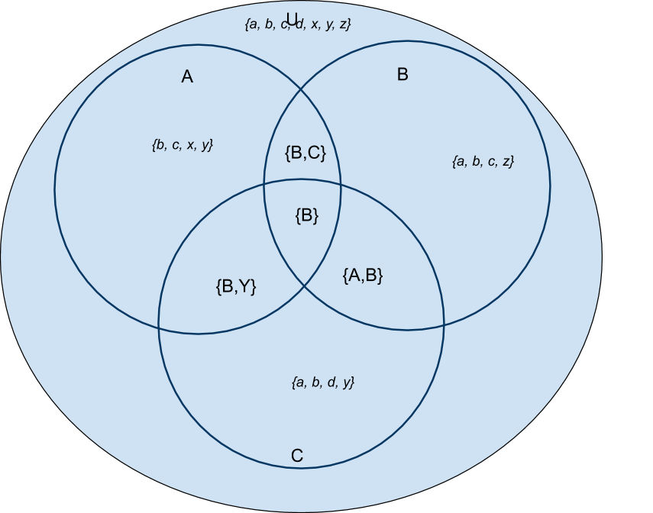

1. (20 points) Set Properties and Operations. Use the following sets to answer the questions.

U = {a, b, c, d, x, y, z} A = {b, c, x, y} B = {a, b, c, z} C = {a, b, d, y}

* 1. (3 pt) Find C – B

{d,y}

* 1. (3 pt) Find B - C

 {c,z}

* 1. (6 pt) Find A ⊕ B

{a,c,d,x} I really dont know what I did here I may have just used C instead of B or A im not sure

* 1. (8 pts) Find $\overset{´}{B⊕C}∨$

{a,b,c,d,x,y,z} – a,b,d,y,c,z = x

x + a,b I didnt see the || so I just did the operation set instead of the

{a,b,x} Cardinality so 3 for a, b and x

1. (18 points) Cartesian Product of sets. Use the following sets to answer the questions.

A = {1, 2, 3, 4, 5}

B = {x, y, z, w}

C = {q, r, s, t}

* 1. (3 pt) T / F (5, s)  A x C

A  5 and C  s

T

* 1. (3 pt) T / F (q, 5)  B x A

A  5 B not  q

F

* 1. (3 pt) T / F (r, r)  B x B

B not  r

F

* 1. (3 pt) T / F (t, s, 4)  C x B x A

B not  s

F

* 1. (6 pt) Find **|** A x B **|**

{(1,x), (1,y), (1,z), (1,w) I didnt see the || and because of that I didnt

(2,x), (2,y), (2,z), (2,w) know it was supposed to be the Cardinality

(3,x), (3,y), (3,z), (3,w) so really it would have been the cardinality (4,x), (4,y), (4,z), (4,w) of A time the cardinality of B 5*4=20

 (5,x), (5,y), (5,z), (5,w)}